Contents

**Introduction to analysis** 2

**Analysis methodology** 3

Soft System Approach 3

Feasibility Study 8

**Requirement Analysis** 10

Functional Requirement 10

Non-Functional Requirement 13

MoSCoW Prioritization 14

System Requirement Specification 18

**Use Case Diagram** 19

**Natural Language Analysis (NLA)** 24

Initial Class Diagram 25

Tables and Figures

Figure 1 Rich Picture for IlamTeaGarden 4

Figure 2 Admin activity conceptual model 8

Figure 3 User Activity Conceptual Diagram 9

Figure 4 Table Comparing conceptual model and real world 10

Figure 5 Feasibility Study table 12

Figure 6 Functional Requirement Table 15

Figure 7 Non Functional Requirement Table 16

Figure 8 MoSCoW 17

Figure 9 MoSCoW Functional Requirement 19

Figure 10 MoSCoW Non-Functional Requirement 20

Figure 11 Pre Project system requirement 21

Figure 12 Post Project System Requirement 21

Figure 13 User Login System Use Case 23

Figure 14 Admin Login System Use Case Diagram 23

Figure 15 Admin/User Use Case Diagram 24

Figure 16 Admin Functionality Use Case Diagram 24

Figure 17 Products Handling Use Case Diagram 25

Figure 18 Products Order Use Case Diagram 26

Figure 19 NLA Candidate Lists 28

**Chapter 2: Analysis**

# **Introduction to analysis**

In simple terms, analysis is the process determining any given situation. In software development, it is the process of determining the requirements, user expectations, predicting risks and collecting data of all possible factors related to a new or an already launched product. It helps in breaking down the project in manageable chunks or parts which helps to understand the problem aspects. It helps in the estimation of time and budget needed for the project which is an essential part of a project success.

<https://www.quora.com/What-is-the-importance-of-analysis-and-design-in-software-engineering>

The importance of performing analysis on my project are:

* It helps in gathering information about the different aspects of tea farmers and manufacturers business. I.e. their way of business operation, rules and regulations.
* It helps to gather information to check the feasibility of the project.
* It helps to understand the problem being faced by the local people easily.
* <https://www.synapseindia.com/6-stages-of-software-development-process/141>
* It enables to understand the requirement of the local people of the area and develop a project that suits both their requirement and knowledge.
* It also facilitates in clarifying the local people on what they think they want from what they actually need.
* This process will also help my project to understand the market areas that are currently involved in the products related to my project.

# **Analysis methodology**

The type of analysis technique undertaken for project development is known as analysis methodology. There are several approaches to software development namely soft system approach, hard system approach, combined approach etc. Among these methodologies, I am going to undertake soft system methodologies.

## Soft System Approach

This methodology is an approach to system modelling for solving general project problems and developing feasible as well as desirable changes based on a differentiated group of people and other factors of social, cultural, ethical kinds etc. It shows that user interaction in any project is of the same importance as the technical considerations. Unlike other methodologies that analyses “how a system should operate”, this methodology provides a soft analysis on ‘what the system should do ‘and ‘how the system should do it.

Susan Gasson, OR/S Group, Warwick Business School October 1994

<http://cci.drexel.edu/faculty/sgasson/Vita/UseOfSSM.pdf>

The process of soft system approach is carried out in several steps.

**Stage 1**

**Finding out problem**

This step includes activities like interviews and observations to try to understand the problem that the project will be solving as deep and as wide as possible.

As a residence of Ilam myself, I have observed the scenario myself and through them the major problems related to the local products of the place were found to be:

* The local products of the place not getting a proper national market.
* Mediators benefitting from the hard work of the local farmers and manufacturers.

**Stage2**

**Expressing the problem situation**

This step of SSM includes tasks of communication of the problem statement and to validate the analyst’s understanding of the situation and representing them using tools like Rich Pictures.

Rich pictures are used for giving an idea of the different factors that the problem influences and relate those factors. The rich picture of the situation is given in the picture below.

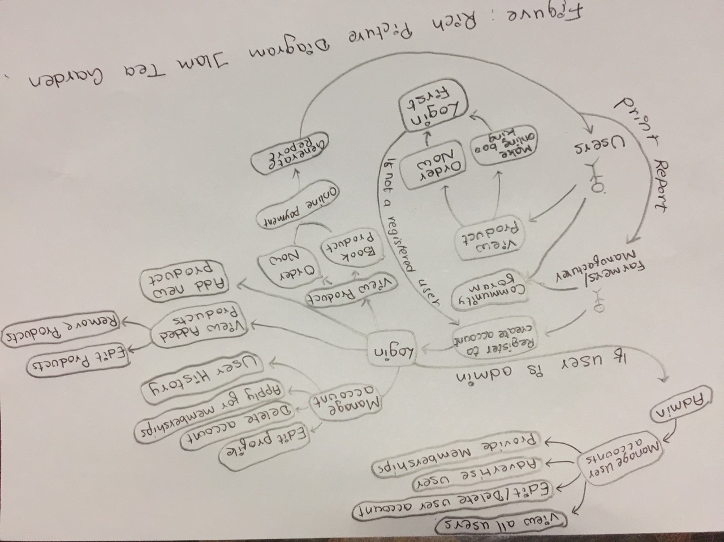

Figure 1 Rich Picture for IlamTeaGarden

**Stage 3**

**Deriving Root Definitions**

Root definition is the process of naming a system, which are short statements that describe the aims and functions of the system to be developed. They are of two types namely

* Primary Task Root Definitions focusing on the process
* Issue-based Root Definitions focusing on the problems.
* **Input-Output Diagrams**

This step of root definitions involves creating possible transformation processes using a single transformation process as much as possible.

Some of the input-output diagrams are shown below.

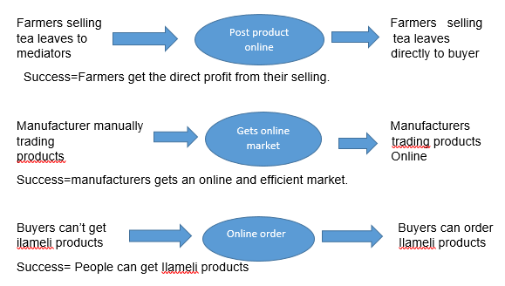

* **Root Definitions (Process based)**

A root definition has been derived from the list of input-out diagrams given above.

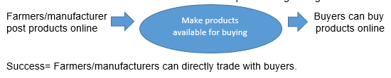

* **Performing the CATWOE Analysis:**

The type of analysis that focuses on the different elements of a project like **C**ustomer, **A**ctors, **T**ransformation, **W**orldview, **O**wner and **E**nvironment factors is known as **CATWOE.** The following elements were drawn out by undertaking this analysis on the project.

1. **C**ustomer = Product Buyers
2. **A**ctors = Farmers and Manufacturers
3. **T**ransformation= Allow direct trading between buyers and sellers.
4. **W**orldview=Farmers and manufacturers is benefitted and buyers get what they want.
5. **O**wners=Project Investors
6. **E**nvironmental constraints=Controlled Educational Environment

* **Root Definitions (Problem based)**

A root definition has been derived from the list of input-out diagrams given above.

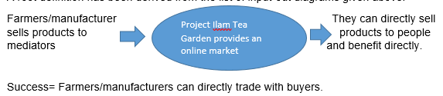

* **Performing the CATWOE Analysis:**

1. **C**ustomer = Product Buyers
2. **A**ctors = Farmers and Manufacturers
3. **T**ransformation= Mediators are eliminated between farmers/manufacturers and product buyers.
4. **W**orldview=Farmers and manufacturers are only benefitted and buyers get what they want.
5. **O**wners=Project Investors
6. **E**nvironmental constraints= Controlled Educational Environment

**Root Definition**

A system owned by project investors, where tea farmers/ local products manufacturer can directly sell their products to interested buyers without any mediators. With a feature of ordering and booking products between the two parties, the system will allow the sellers to get high benefit and buyers get to enjoy the local products of Ilam.

**Stage 4**

**Deriving Conceptual Models**

A conceptual model can be defined as a set of concepts combined to represent a system so as to make the viewer easily understand the different models of the system. It represents the different activities that the actors need to perform for achieving the designated transformations. By listing different activities and graphically relating them using monitor and feedback activities, a conceptual model is designed. The conceptual model for project is given below.

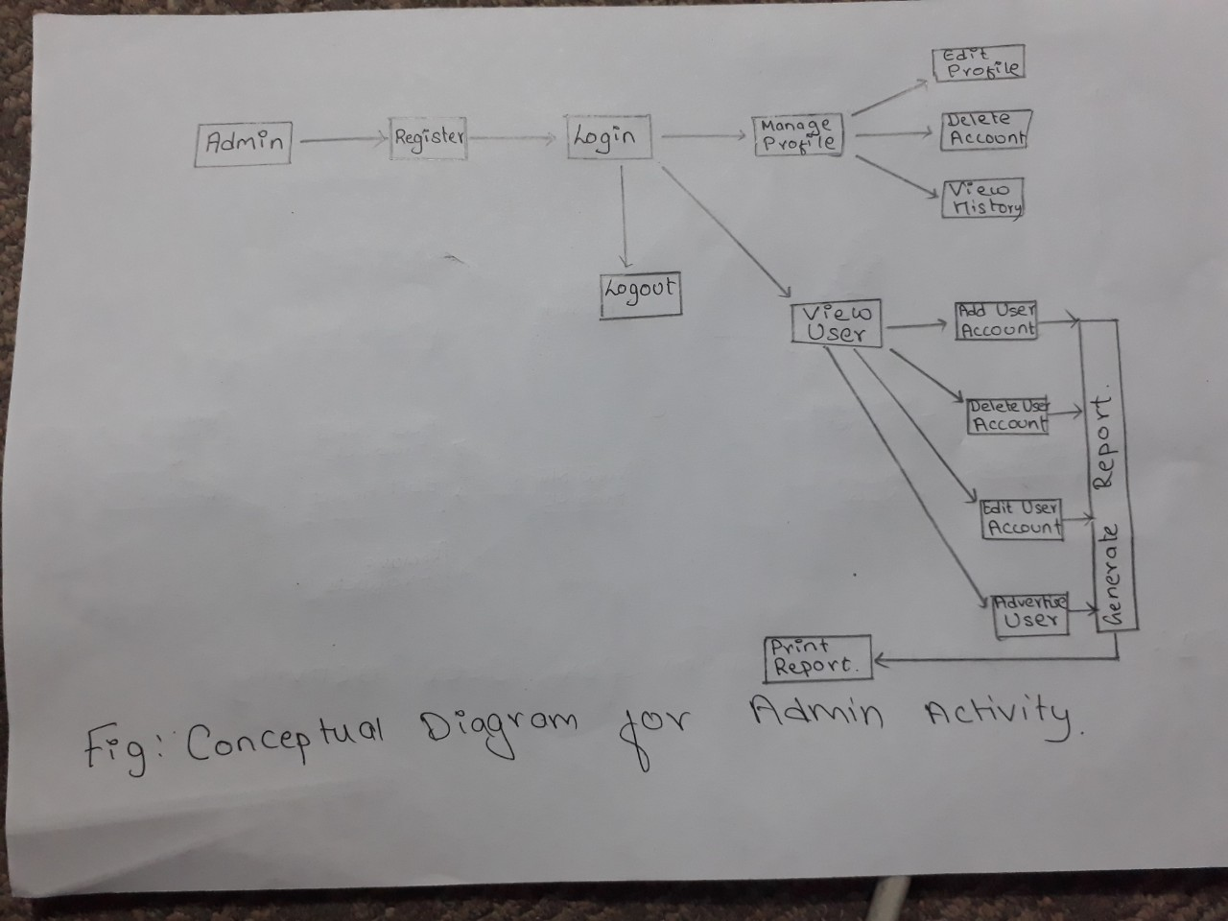

Figure 2 Admin activity conceptual model

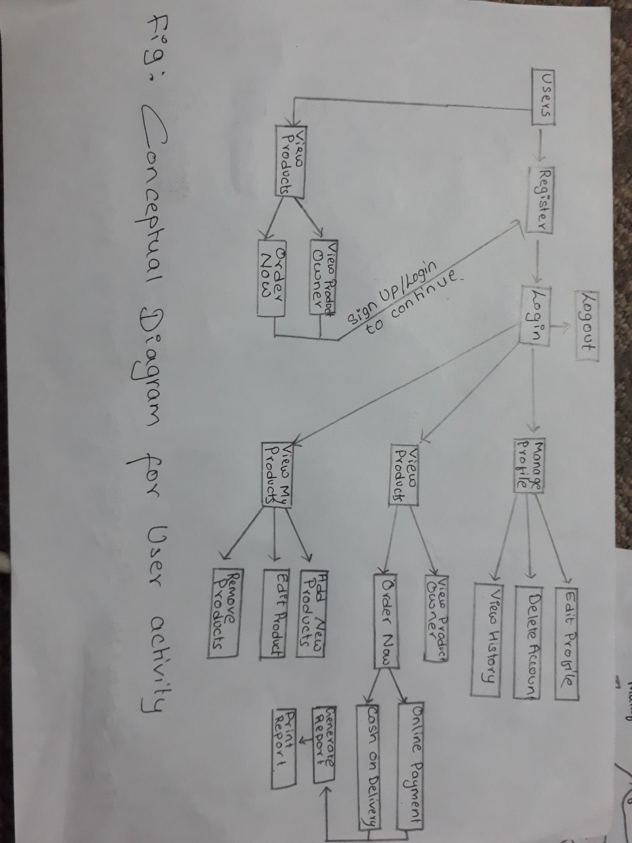

Figure 3 User Activity Conceptual Diagram

**Stage 5: Comparing the concept of the system with the actual system**

This step compares different aspects of a conceptual model with the real project developed since not everything will be pitch perfect and in conjunction to the conceptual model.

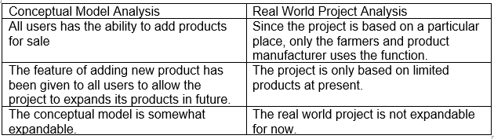

Figure 4 Table Comparing conceptual model and real world

**Stage 6: Analyzing Feasible and Desirable Changes**

This step of SSM follows activities to show the rich picture and conceptual diagram to people who are the major stakeholders of the project and other users who can help analyze the system model with the above diagrams. Some of the changes that have been analyzed are as follows

* The rich picture shows that all users can add products but since the project is based only on Ilam, it was taken into consideration that not all users can add products for sale for now.
* Community forum should link all users and admins to make a trustworthy project.

## Feasibility Study

The study undertaken to find out whether or not a project is practically possible in the real world scenario, its probability to success and its ability to do what a project aims for is known as feasibility study. These factors can be determined by understanding the cost, times and benefits related to the project. For a project to be successful, the project should have the ability to achieve its purpose with the benefit always greater than the cost required for the project.

The different feasibility study that I performed in my project are given in the table below.

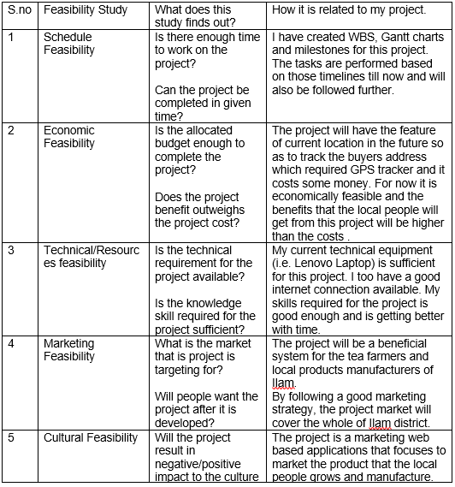

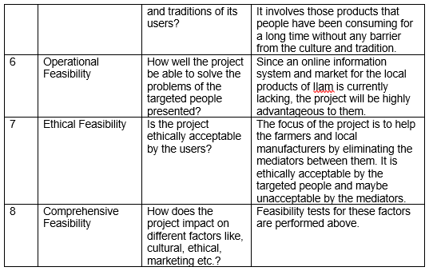

Figure 5 Feasibility Study table

# **Requirement Analysis**

## Functional Requirement

Functional requirement in project development are those features which are planned to be incorporated in a system being made. These requirements include technical features, hardware-software and their functionality to operate as per the needs of the system user.

The functional requirements of my project is introduced below along with its rationale and dependencies.

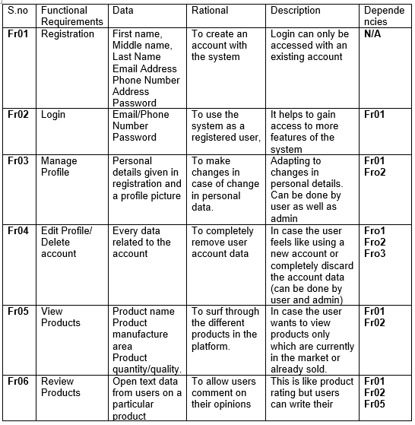

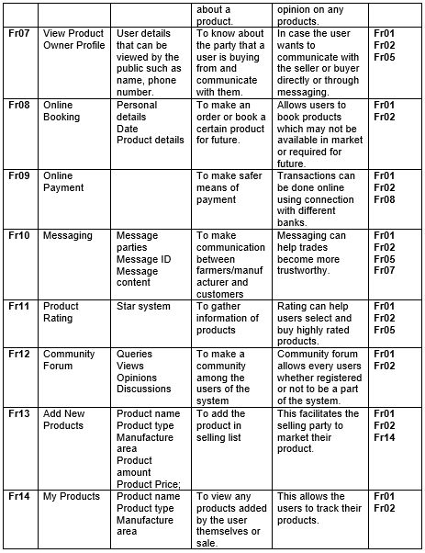

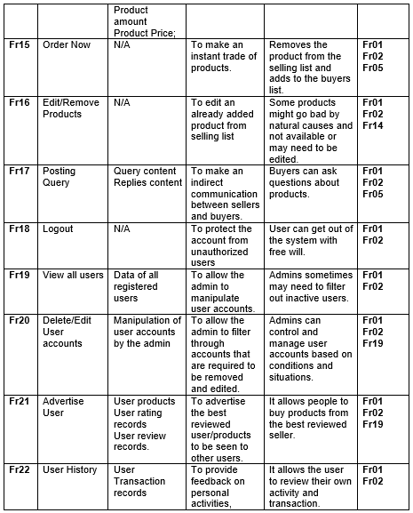

Figure 6 Functional Requirement Table

## Non-Functional Requirement

Those requirements that sets up specific criteria for judging the operation of a developed system is known as non-functional requirements. These non-functional requirements usually determine the quality attributes of the system rather than some specific behavior or functions.The non-functional requirement of my project is shown in the table below.

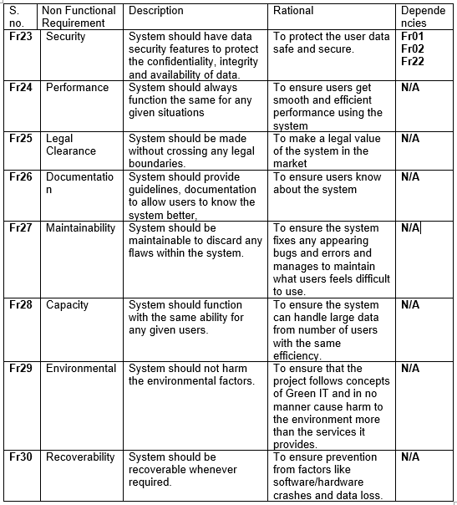

Figure 7 Non Functional Requirement Table

## MoSCoW Prioritization

Commonly referred as MoSCoW method, it is the technique for prioritizing requirements of a system. The level of priority for a system are Must Have, Should Have, Could Have and Won’t Have. This method determines what requirements are compulsory, optional and what a system will not have. This method is also applicable in our life represented by the figure below.

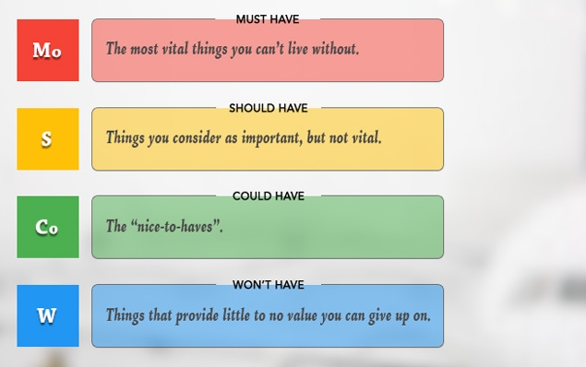

Figure 8 MoSCoW

The table below shows the prioritization of different functional requirements of my project.

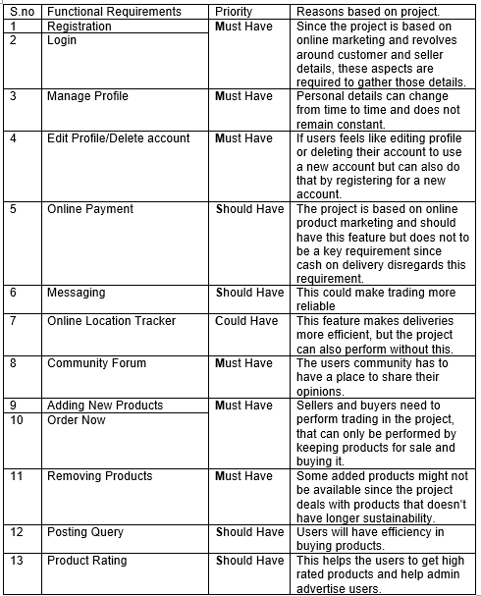

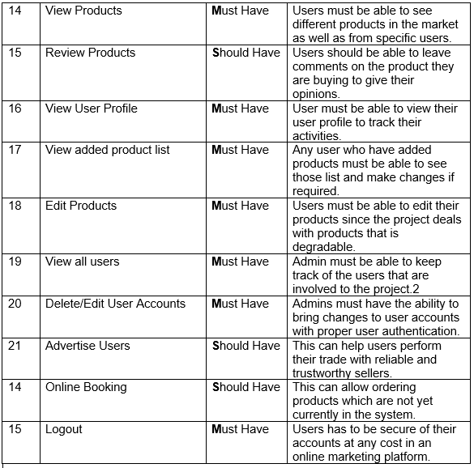

Figure 9 MoSCoW Functional Requirement

The table below shows the prioritization of different non-functional requirements of my project.

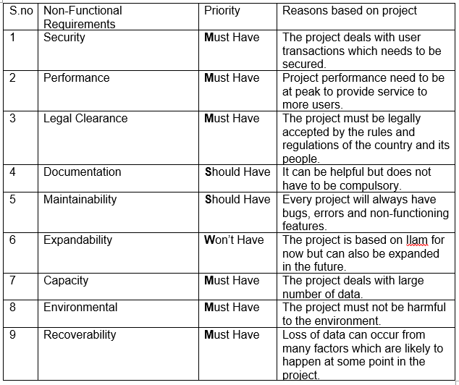

Figure 10 MoSCoW Non-Functional Requirement

This analysis conducted in my project gave the following information.

* It identified key requirements of my project.
* It identified any aspects that my project doesn’t require right now.
* It helped to identify future aspects of my project.

## System Requirement Specification

A system Requirement Specification is a set of documents details the features and functionality of a system to be developed. It also provides details on different hardware and software required while developing the project as well as what users will require to use the project.

The hardware/software requirements for my project is given below.

* Pre-project requirements

The hardware/software required for developing the project from initiation to deployment is known as Pre-project requirements.

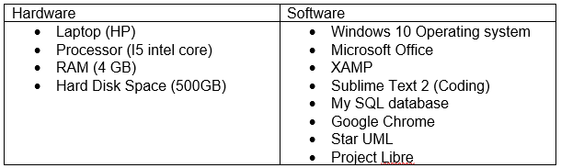

Figure 11 Pre Project system requirement

* Post project requirements

The hardware/software that is required at minimum to use the project by the user is known as post project requirement.

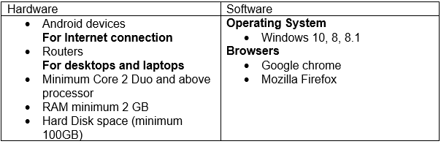

Figure 12 Post Project System Requirement

# **Use Case Diagram**

A use case diagram is a diagrammatic representation of the different entities of a system. It clarifies the role of different external parties on the functionality of the system commonly called actors. It is made to show the relationship of the external entities with the different aspects of the system shown in different use cases.

The advantage of creating this diagram on my project are as follows.

* It is an easy and understandable method of representing a system to the local people since it doesn’t have any technicality.
* Use cases evolve with each iteration and change in requirements can be traced easily.
* It helps to identify the role of different entities like farmers and manufacturers, customers and admin in a clear way.
* It shows the relationship of these entities with different functionalities

The use case diagram of my project is given below.

1. User Login System Use Case

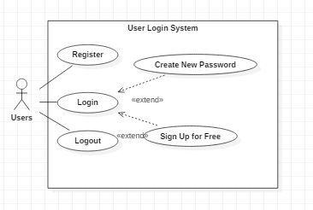

Figure 13 User Login System Use Case

Unregistered users will have to register their account first to create and account. After they are registered, they can login to the system. If in any case, the user forgets their password or need to sign up with another account, they can create a new password or sign up for free respectively as shown by the extend relation.

1. 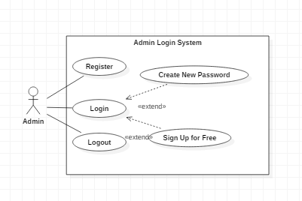Admin Login System Use Case.

Figure 14 Admin Login System Use Case Diagram

Users at first need to be registered as admin. After they are registered, they can login to the system. If in any case, the admin forgets their password or need to sign up with another account, they can create a new password or sign in respectively as shown by the extend relation.

1. Admin/Users Profile Use Case Diagram

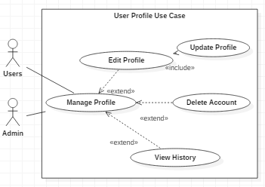

Figure 15 Admin/User Use Case Diagram

Both admin and users can manage their profiles in the system. They can edit their profile details, delete their account as well as view their activity history as shown by the extended relation. To update their profile though, both admin and users compulsorily need to make changes to profile as shown by the include relation.

1. Admin Functionality Use Case Diagram

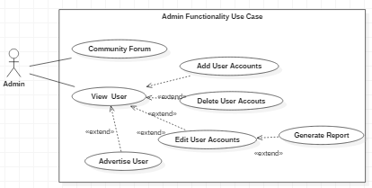

Figure 16 Admin Functionality Use Case Diagram

Admin can participate in the community and view all users. Admin can manipulate users by adding new users, delete user accounts, edit user accounts as well as advertise deserving users as shown by the extended relation below. It is compulsory to edit user accounts in order to generate report which is shown by the include relation.

1. Products Handling Use Case Diagram

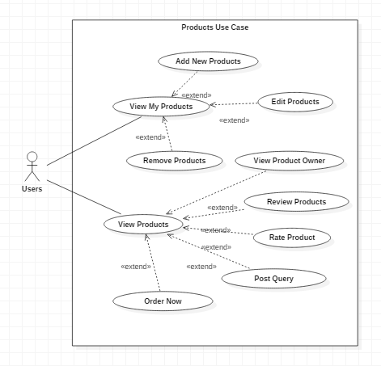

Figure 17 Products Handling Use Case Diagram

Users can either view products that are on sale or view their own products that are for sale. They can add new products, edit their products details as well as remove products based on circumstances as shown by the extended relation. After viewing products that are at sale users can view the product owner profile, review the products, rate the product, post any query and order the product as shown by the extended relation.

1. Product Order Use Case Diagram

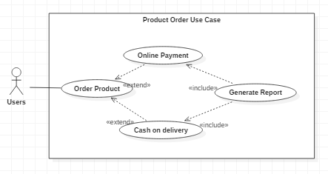

Figure 18 Products Order Use Case Diagram

After users order a certain product, they can either make an online payment or choose to pay can on delivery as per their needs. To generate payment reports it is necessary to perform these as shown by the include relation.

# **Natural Language Analysis (NLA)**

The process of identifying the different aspects of a system by using an unstructured text that are completely understandable to non-technical people is known Natural Language Analysis. It revolves around an unstructured text where nouns are selected as potential object candidates, verbs are selected as potential candidate methods and adjectives are selected as potential attributes. These three factors later help in the creation of different diagrammatic figures like class diagram, activity diagram, system architecture etc. These diagrams in turn play key roles for development of a system.

To perform Natural Language Analysis, an unstructured text related to the project is required. The scenario for my project is presented in the unstructured text below

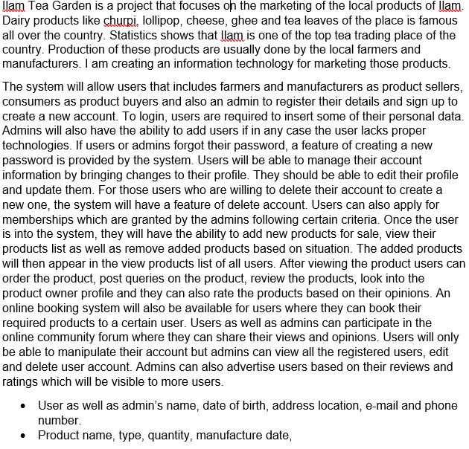

From the unstructured text given above **NLA** will be carried out in the following steps.

* Selection of nouns as potential candidate classes
* Selection of adjectives as potential candidate attributes
* Selection of verbs as potential candidate methods

The candidate classes, attributes and methods have been shown in the table below.

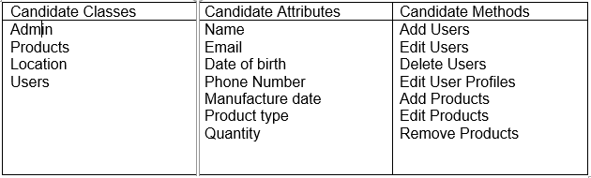

Figure 19 NLA Candidate Lists

## Initial Class Diagram

A class Diagram is a graphical representation of the blueprint of the system that shows the relationship between different classes, attributes and methods. A 3 section rectangular box is used for class diagram in which classes are kept at the top section, attributes in the middle section and methods or functions in the bottom section. These unique classes are then connected via different relationship types and thus this diagram is used in the implementation of the whole system.

